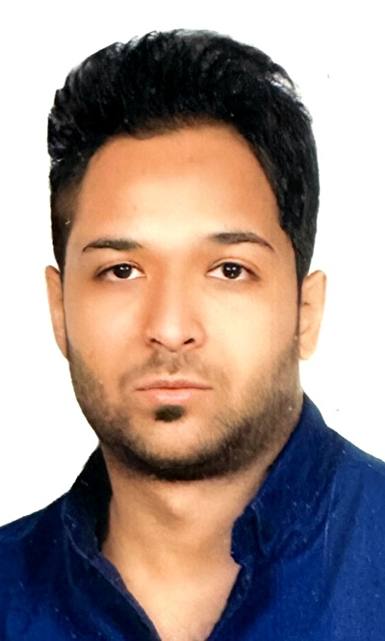

Curriculum Vitae
Full Name: Hamid Reza Nasiri Dahej
Date of Birth: April 25, 1988
Phone: +98 921 150 0132 (WhatsApp available)
Email: hamidrezanasiri008@gmail.com
Address: No. 435, 4th Floor, Unit 7, Golayel Alley, Othar St., Sayad Shirazi Blvd, Eram Blvd, Mehrshahr, Karaj, Alborz, Iran

Career Objective
Motivated and detail-oriented accounting and finance professional seeking to advance my expertise in an international, transparent, and dynamic environment. I aim to contribute to the organization’s success while enhancing my knowledge of global accounting standards and practices.

Education
- Bachelor’s Degree in Business Accounting
- Master’s Degree in Financial Management

Work Experience
Iran Mineral Processing Research Center (2016 – Present)
Position: Financial Expert
- Recording and auditing sales invoices in the Taxpayers System
- Analyzing financial documents and preparing journal entries
- Preparing monthly and annual financial reports
- Managing accounts receivable and payable, inventory control
- Reviewing and managing procurement documents in the Government Procurement System

Skills
- Proficient in accounting software (Rahkaran)
- Skilled in Microsoft Office (Excel, Word, PowerPoint)
- Knowledge of financial reporting and document management
- Inventory and procurement management
- English: Pre-Intermediate

Certificates
- General Ledger and Accounting Software (Rahkaran) Training

