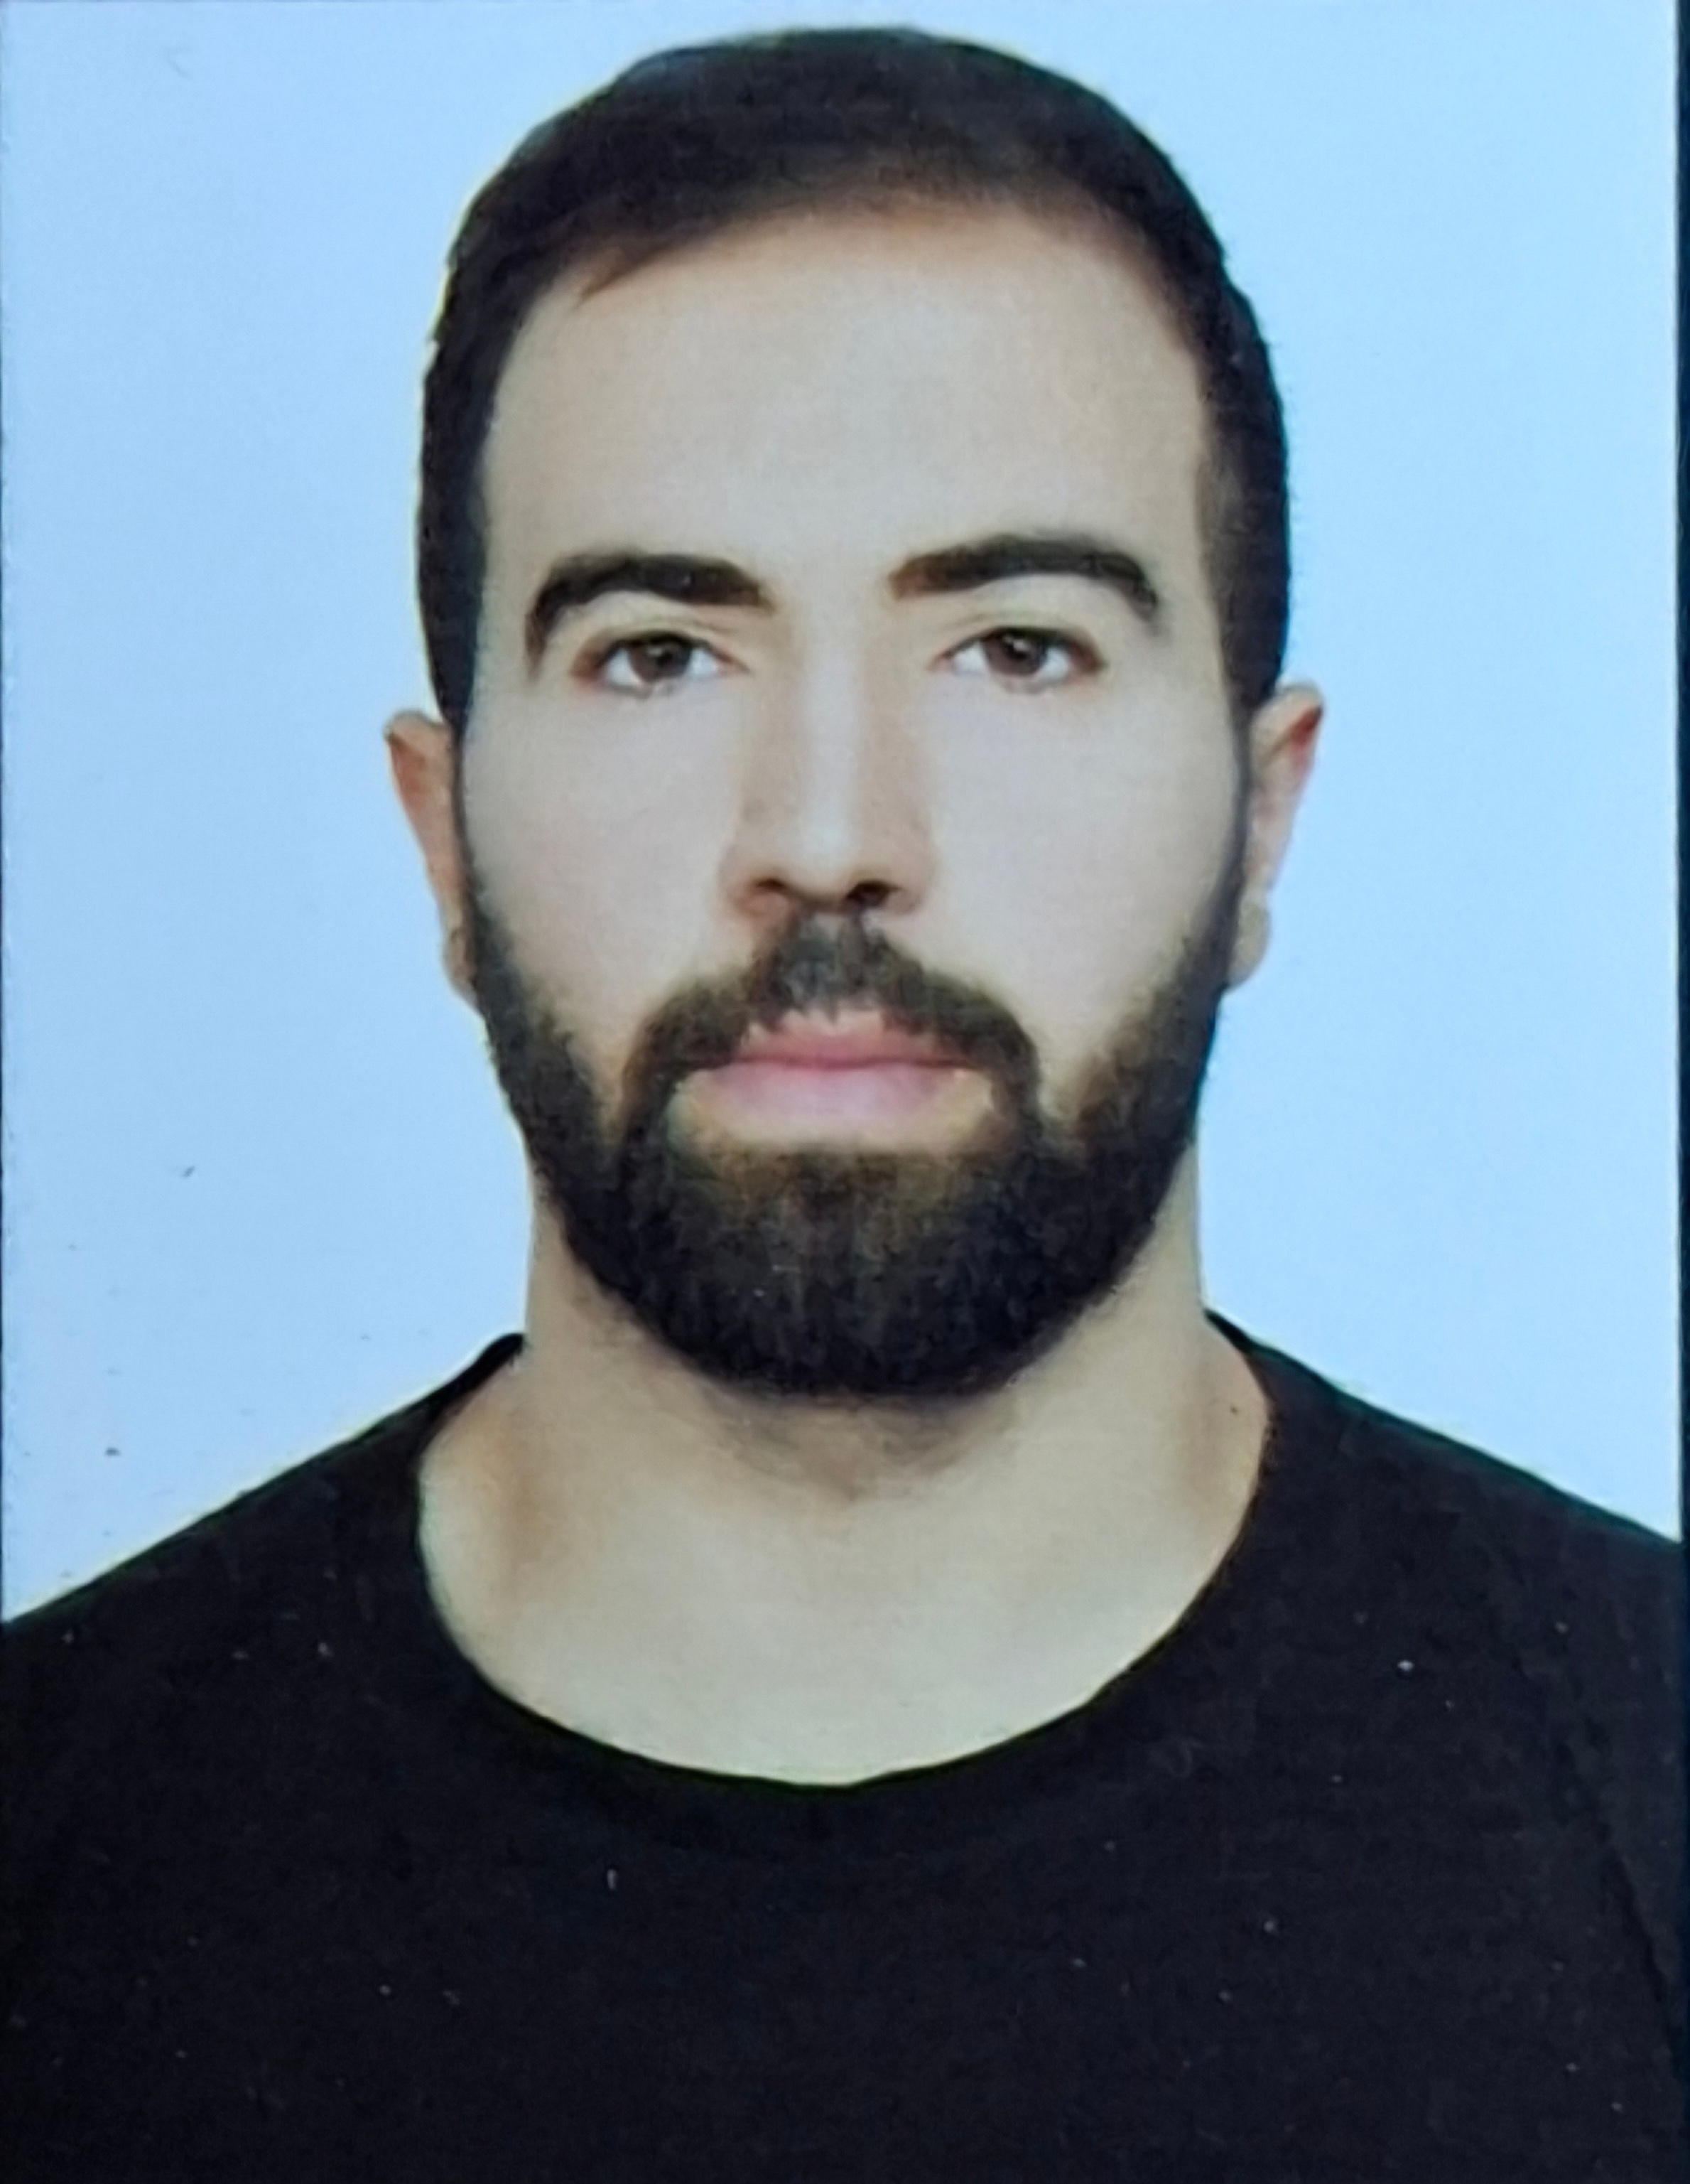
SEYED ALI Mojri
Mob: 0551453737
E-mail: alimojri@yahoo.com
Alimojri15@gmail.com

Personal Summary
Organized individual with excellent and pleasing attitude to experienced as a Salesman . Organized individual with excellent customer service. Able to communicate effectively with a range of different people in high pressure situations. FLUENT IN ENGLISH-ARABIC-PERSIAN.
knows Dubai roads very good
Work Experience
- 1 Year experience in VIRGIN, Dubai, as a Salesman.
- 6mounts experience in sharfdj dubai as salesmen
- He is well knowledge in Smart Phones- Soft Ware and Hardware.
- Good Knowledge in Computer Hardware and Software.
- Very good Knowledge and experience in Electronics Items and Cars.
- Worked in jumbo electronics for four months
- Two months experience in xiaomi mobiles as salesmen
- 4 months in Samsung store
- Served in military of Iran for 3 years in commando team
- Worked in the ice factory back in country for 6 months
- Was in the construction work for 5 months
- Worked in noon for two months as delivery guy
- Experienced in dubai roads and it's rules.
- Worked in T chocolate company as delivery guy
Skills and Qualities
- Dealing with customer concerns and complaints in an effective way.
- Communicates well with a variety of different people at all levels.
- Able to work well within a team.
- Able to pick up new processes quickly and efficiently.
- Able to work on heavy pressure
- Super active all the time.
- Professional swimmer mix martial arts plus bodybuilder.
UAE DRIVING LICENCE (MANUAL)
Licence No : 63664381
Issue Date : 23-05-2017
Expiry Date : 23-05-2023
Education
2012 – 2014: High Schooling - Iranian School, Dubai.
2016-2017 : I.T. Diploma, Iranian School, Sharjah.
Personal Details.
DATE OF BIRTH : 29-07-1996
NATIONALITY : IRANIAN
PASSPORT NO : M73115583

I born in Iran, after 6 months of my birth, my parents and myself, we came to Dubai and done my schooling and my higher education in Dubai and then went back to my country to serve it and now iam back.

SEYED ALI mojri

